UTIMCO Coding Challenge Documetation

**Version 1.4**

03-Dec-2017

Table of Contents

1. Getting Started 3

1.1 Configuring Environment with Eclipse IDE 3

1.2 Setting Eclipse Environment 4

1.3 Download and Extract Coding Challenge File 4

2. Open and Configure Coding Challenge Project 5

2.1 Import Coding Exercise to Eclipse IDE 5

2.2 Import the Simple JSON API 6

3. Execute Coding Challenge Project 8

4. References 9

# Getting Started

## Configuring Environment with Eclipse IDE

This Java package was built using the latest Eclipse IDE in the Oxygen release. If you need Eclipse Oxygen do the following:

* Open a web browser and go to <https://www.eclipse.org/downloads/packages/release/Oxygen/1A>
* On the Eclipse Oxygen IDE download page select “Eclipse IDE for Java Developers”:

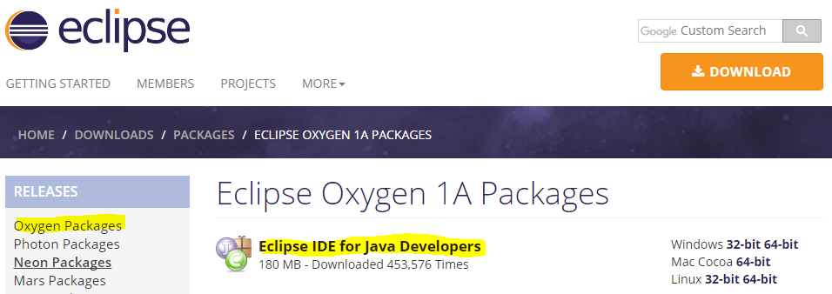

* On the right side of the screen select the download link for your specific system:

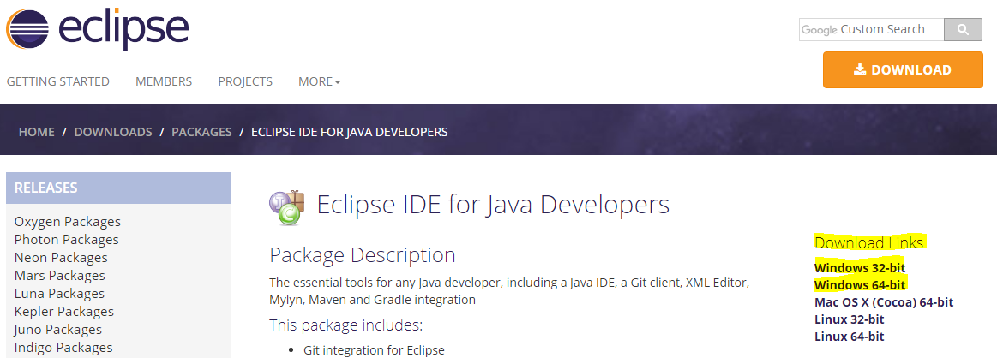

* Click Download
* After the file has finished downloading, extract the file to C:\Program Files (x86)
* After the folders have been extracted, navigate to C:\Users\ryantbs23\Downloads\eclipse-java-oxygen-1a-win32-x86_64\eclipse and double click eclipse.exe to lauch Eclipse IDE

## Setting Eclipse Environment

When Opening Eclipse IDE for the first time, it will ask you what directory to use as a workspace. Please chose the default for the purposes of this exercise and select launch:

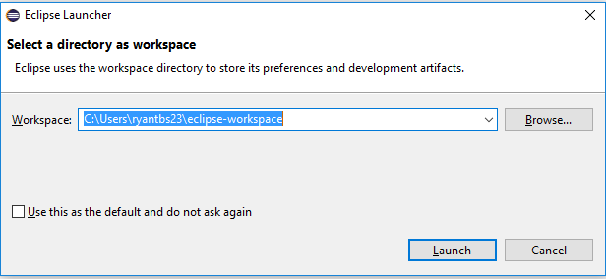

## Download and Extract Coding Challenge File

* Download the following .zip file and extract it to C:\RyanBennettCodingExcercise



# Open and Configure Coding Challenge Project

## Import Coding Exercise to Eclipse IDE

After you have downloaded UTIMCO Coding Exercise.zip, json-simple-1.1.jar and have your Eclipse IDE installed and open, proceed with the following steps:

* In Eclipse IDE select File 🡪 Open Project from File System

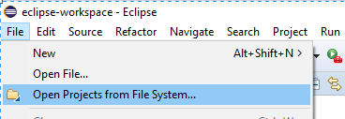

* In the new window, copy and paste C:\RyanBennettCodingExcercise\UTIMCO Coding Exercise in the Import Source field. Ensure that the checkboxes are selected for “Search for nested projects” and “Detect and configure project natures” and click Finish

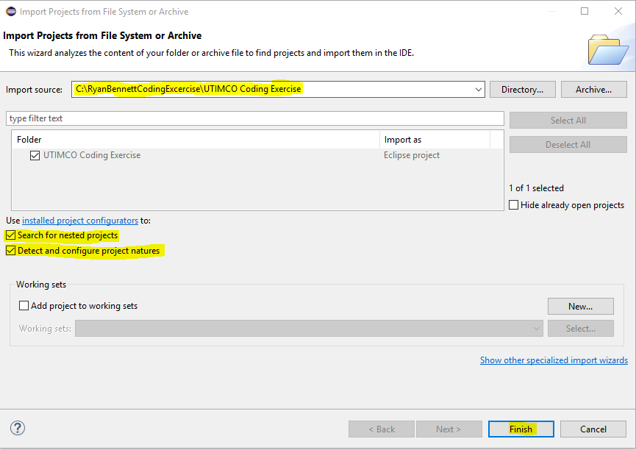

* You will now see the UTIMCO Coding Exercise project open in the Package explorer on the left side of Eclipse IDE

## Import the Simple JSON API

Before we can execute the Java for the UTIMCO Coding Challenge, we need to import the Simple JSON API. This step may be optional if you’ve imported or worked with the Simple JSON API before:

* Right click on the UTIMCO Coding Challenge project in the Package Explorer menu in Eclipse IDE and select Properties

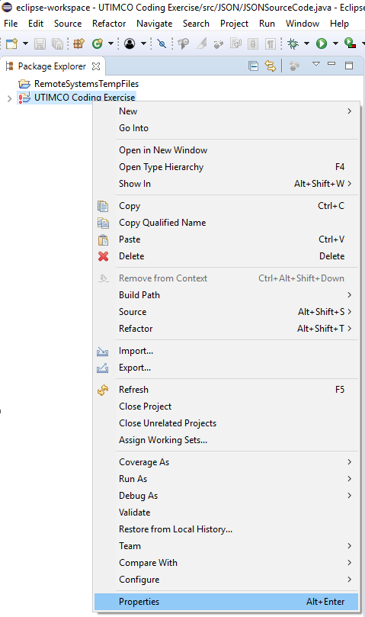

* In the new Properties window, navigate to Java Build Path 🡪 Libraries and click “Add External JARs” button

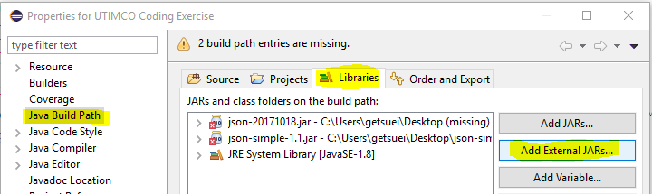

* In the JAR Selection window navigate to C:\RyanBennettCodingExcercise\Simple JSON API\ and select json-simple-1.1.jar. Then click “Open” and “Apply and Close”

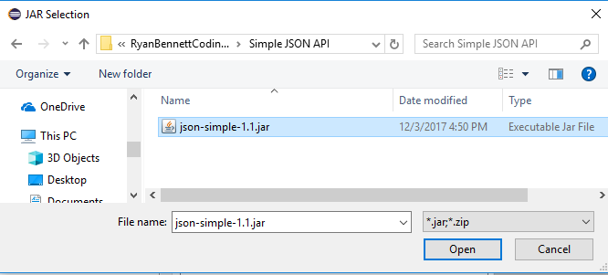

# Execute Coding Challenge Project

To execute the Java solution for the UTIMCO Coding Challenge project do the following:

* In Eclipse IDE in the Package Explorer window expand UTIMCO Coding Exercise 🡪 src 🡪 JSON 🡪 [double click] JSONSourceCode.java to open the project file

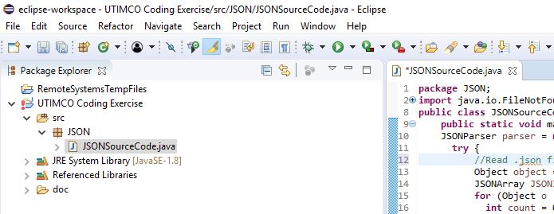

* To execute the project, click the arrow next to the green play arrow icon in the top of Eclipse IDE near the middle

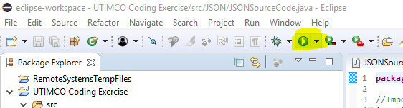

* This completes the exercise. The result set will be output into the Console window at the bottom of Eclipse IDE. If you wish to view the source JSON file and data in Eclipse IDE, in Package Explorer navigate to UTIMCO Coding Challenge 🡪 doc 🡪 [double click] JSONSourceCodeCleanup.json

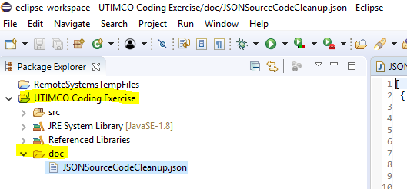

# References

How to import and API to an Eclipse IDE project:

<https://stackoverflow.com/questions/5698900/add-json-package-reference-new-to-java>

How to read JSON file in Java with the Simple JSON Reader

<http://www.javainterviewpoint.com/read-json-java-jsonobject-jsonarray/>

Accessing Members of items in a JSONArray with Java

<https://stackoverflow.com/questions/1568762/accessing-members-of-items-in-a-jsonarray-with-java>

How to read JSON file into Java with Simple JSON library

<https://stackoverflow.com/questions/10926353/how-to-read-json-file-into-java-with-simple-json-library>

Coding Challenge Solution in PHP:

<https://github.com/schrodervictor/codeeval-challenges/tree/master/easy/Json-Menu-Ids>

Document Revision History

|  |  |  |  |
| --- | --- | --- | --- |
| **Version Number** | **Date Updated** | **Revision Author** | **Brief Description of Changes** |
| 1.0 | Dec 03, 2017 | Ryan Bennett | Created original document |
|  |  |  |  |
|  |  |  |  |